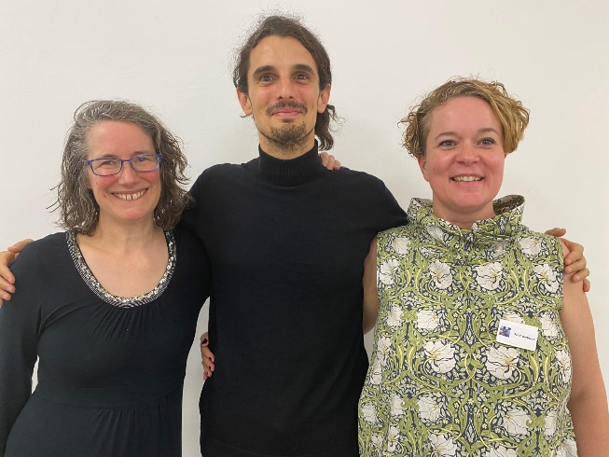
AMOPA Talk Series

ADEFFI Talk with

Dr Sarah Berthaud

Lecturer in French, ATU Galway

& Mr Giaime Lazzari

Doctoral student, Trinity College Dublin

! Talk in French!

11 March 2026

@ 7pm (Dublin Time)

Register and join Zoom
[xxx]
On 11 March 2026, AMOPA Irlande will have the pleasure to host a dialogue with Dr Sarah Berthaud and Mr Giaime Lazzari about the ADEFFI (the Association Des Etudes Françaises et Francophones d’Irlande).
In a first part, Dr Berthaud will talk about French and Francophone Studies in Ireland and beyond: How the ADEFFI plays an important role in promoting research and collegiality. Sarah will present the ADEFFI, including its aims, its recent activities, and its evolution over the past 3 years during the mandate she served as president. The continued links between the ADEFFI and associations such as the AMOPA will be highlighted. She will also give an overview of her current research and show how the ADEFFI provides a rewarding and inspiring association for academics in French and Francophone studies, even if, or can we say, especially if, they engage with inter and multidisciplinary research. She will focus on her two main research strands: applied languages/linguistics and textile/fashion tourism.
Dr Berthaud is a Lecturer in French at the Atlantic Technological University, Galway City and is a professional French<>English translator-interpreter. A trained linguist but also an avid textile addict, her current research focusses on second and bilingual language teaching and learning, language policy, and textile/fashion tourism.
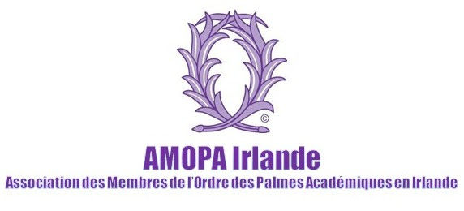
In a second part, Giaime Lazzari will talk about The Archive as Laboratory: Funding, Research, and the Case of Daniel Drode. After a brief presentation of his research, Giaime will address the importance of the bourse doctorale in funding his stay in Paris to undertake archival work at the Bibliothèque nationale de France in October 2025. He will describe the specific archival questions that guided this stay, particularly his investigation of the Fonds Daniel Drode (NAF 28454), and the ways in which previously unexplored materials — including preparatory notes, variant drafts, and unpublished marginalia — have informed his understanding of Daniel Drode’s Surface de la planète (1959; 1976) as a work in which textual materiality is constitutive of science-fictional world-building. He will also provide a personal report on the 2025 ADEFFI conference in Toulouse, reflecting on the feedback and discussion that emerged in response to his presentation, and on how those exchanges have shaped subsequent stages of his project. Ultimately, he will argue that the combination of archival research and scholarly dialogue, enabled by the ADEFFI and AMOPA supports, has been crucial for advancing a new line of inquiry in French science-fiction studies. Giaime Lazzari is a PhD candidate in French literature at Trinity College Dublin, where he is the recipient of the Claude and Vincenette Pichois Research Award for 2024-2028. He is the 2025 lauréat de la bourse doctorale ADEFFI sponsored by AMOPA.

